

|  |
| --- |
| Prototype1 |
| 28/08/16 18:24 |
| **Author:** John Doe  **File name:** Prototype1.vp  **Version** 1.0 |

|  |
| --- |
| Site Map |
|  |

|  |
| --- |
|  |

01. Site Map / Prototype1 

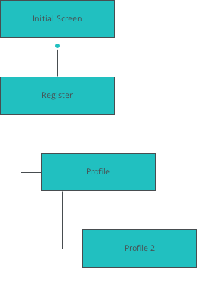

|  |
| --- |
| Screens |
|  |

|  |
| --- |
|  |

02. Screens / Prototype1 

Initial Screen

|  |
| --- |
|  |

Interactions

|  |  |
| --- | --- |
| 1 | **on Click:** goes to 'Register' 🡪 |

02. Screens / Prototype1 

Pairing Mode

|  |
| --- |
|  |

02. Screens / Prototype1 

Pairing Mode 2

|  |
| --- |
|  |

02. Screens / Prototype1 

Profile

|  |
| --- |
|  |

Interactions

|  |  |
| --- | --- |
| 2 | **on Click:** goes to 'Profile 2' 🡪 |

02. Screens / Prototype1 

Profile 2

|  |
| --- |
|  |

02. Screens / Prototype1 

Register

|  |
| --- |
|  |

Interactions

|  |  |
| --- | --- |
| 3 | **on Click:** goes to 'Profile' 🡪 |

|  |
| --- |
| Templates |
|  |

|  |
| --- |
|  |

03. Templates / Prototype1 

Template 1

|  |
| --- |
|  |

|  |
| --- |
| Scenarios |
|  |

|  |
| --- |
|  |

04. Scenarios / Prototype1 

default

|  |
| --- |
|  |